Docker
🐳 What is Docker?
Docker is a software platform that allows you to build, package, and run applications in containers.
👉 A container includes:
- Application code
- Required libraries
- Dependencies
- Runtime environment
So the app runs the same everywhere (your laptop, server, cloud).

🧠 In One Line
👉 Docker = Tool to run applications in isolated, portable containers

🌍 Real-Life Example (Easy Understanding)
Imagine you create a project on your laptop:
- Python version = 3.10
- Flask installed
- Some libraries
Now when you send it to your friend:
- They have Python 3.8 ❌
- Missing libraries ❌
- App crashes ❌

✅ With Docker
You pack everything into a container:
- Same Python
- Same libraries
- Same setup
👉 Your friend just runs:
docker run myapp

🖥️ What is Virtualization?
👉 Virtualization means creating a virtual (fake) version of something physical, like a computer, server, or operating system.
Instead of using one physical machine for one task, virtualization allows one machine to run multiple systems.

🧠 In One Line (Exam Ready)
👉 Virtualization is the technology that allows multiple virtual machines (VMs) to run on a single physical machine by sharing its resources.

🌍 Real-World Example
Imagine you have one big house 🏠:
- Without virtualization → Only one family can live there
- With virtualization → You divide it into multiple rooms (virtual homes)
- Each family lives independently
👉 Same way:
- One computer → multiple virtual systems

💻 Technical Example
You install software like:
- VMware
- VirtualBox
Now your laptop runs:
- Windows (main OS)
- Linux (virtual OS)
👉 Both run at the same time

🔄 Types of Virtualization
1. Virtual Machines (VMs)
- Each VM has its own OS
- Heavy (needs more memory & CPU)

🐳 Virtualization in Docker (Important!)
Docker uses a lightweight form of virtualization called “containerization.”

📦 3. CONTAINERIZATION

🧠 Definition
👉 Containerization runs applications in lightweight environments (containers) without full OS

⚙️ Key Idea
- Containers share host OS
- Only include:
  - App
  - Dependencies

🌍 Real Example
Instead of:
- Giving each person a full house (VM)
👉 Give:
- Separate rooms in same house (containers)

💻 Technical Insight
- Uses Linux kernel features
- No need for full OS

🔥 Why Containers?
Because VMs were:
- Slow
- Expensive
- Hard to scale
👉 Containers solve:
- Portability
- Speed
- Efficiency

⚙️ 4. CONTAINER RUNTIME

🧠 Definition
👉 Software that actually runs containers

⚙️ Responsibilities
- Create container
- Start/stop container
- Apply isolation
- Manage resources

🌍 Real Example
- Container image = packed food 🍱
- Runtime = person cooking/serving

💻 Examples
- Docker Engine
- containerd
- CRI-O

🔒 5. PROCESS ISOLATION & NAMESPACES

🧠 Concept
Containers should behave like:
👉 “They are alone in the system”
This is achieved using Namespaces

⚙️ Types of Namespaces

🔹 1. PID Namespace
👉 Process isolation
- Each container sees its own processes
- Cannot see others
📌 Example:
Inside container:
ps
Only its processes visible

🔹 2. Network Namespace
👉 Separate networking
- Own IP
- Own ports
📌 Example:
Multiple containers use port 80 without conflict

🔹 3. Mount Namespace
👉 Separate filesystem
- Changes inside container don’t affect host

🔹 4. UTS Namespace
👉 Separate hostname

🔹 5. User Namespace
👉 Security mapping

🌍 Real Example
Train 🚆:
- Same engine
- Different compartments
- Passengers don’t interact

🧠 Key Line
👉 Namespaces = Isolation

⚡ 6. CONTROL GROUPS (CGROUPS)

🧠 Concept
👉 Control how much resources a container can use

⚙️ Controls:
- CPU
- Memory
- Disk I/O

🌍 Real Example
Electricity meter ⚡:
- Each house has limit
- No one can use everything

💻 Example
docker run -m 100m nginx
👉 Limits memory to 100MB

❗ Why Needed?
Without cgroups:
- One container can crash whole system

🧠 Key Line
👉 Namespaces = isolate
👉 cgroups = control

Docker Image
✅ Definition
A Docker Image is a read-only template that contains everything needed to run an application — code, libraries, dependencies, and environment setup.

💻 Technical Example
- You create an image using a Dockerfile:
FROM python:3.9
COPY app.py .
CMD ["python", "app.py"]
👉 This image includes:
- Python runtime
- Your app code
- Required dependencies
➡️ Command to build image:
docker build -t myapp .

🌍 Real-World Example
Think of an Image like a “recipe” 🍲
- Recipe = Instructions + Ingredients
- You don’t eat the recipe directly
- You use it to prepare food
👉 Similarly:
- Image = blueprint of app
- It is not running yet

🔹 2. Docker Container
✅ Definition
A Docker Container is a running instance of a Docker Image.
It is a lightweight, isolated environment where the application actually executes.

💻 Technical Example
Run the image:
docker run myapp
👉 This creates a container:
- Executes your app
- Has its own filesystem, network, processes

🌍 Real-World Example
Think of a Container like the actual “cooked dish” 🍛
- You cook food using a recipe
- You can eat and use it
👉 Similarly:
- Container = running app
- You can interact with it
Example:
🎯 Super Short Difference
Image = Recipe / Blueprint
- A recipe book tells you how to cook a dish
- It contains instructions but is not the actual food
✅ Example:
“Maggi recipe written on paper”
👉 Container = Cooked Food
- The actual dish you cook and eat
- It is the final running result
✅ Example:
“Cooked Maggi in a bowl ready to eat”
👉 Image = Instructions (Recipe)
👉 Container = Result (Cooked Food)
🧩 Docker Image (Technical)
👉 A Python web app image
FROM python:3.9
COPY app.py .
CMD ["python", "app.py"]
- This image contains:
  - Python runtime
  - Your app.py code
  - Required environment
✅ It is not running yet (just a template)

🚀 Docker Container (Technical)
👉 Run the image:
docker run my-python-app
- This creates a container
- Your Python app starts executing
- It becomes a running process

👉 Image = Stored application (code + dependencies)
👉 Container = Running application (execution environment)

🧱 8. IMAGE LAYERS

🧠 Concept
Images are built in layers

⚙️ Each Dockerfile instruction = layer

🌍 Real Example
Cake 🎂:
- Base layer
- Cream
- Topping

✅ Benefits
- Faster builds
- Saves storage
- Reusability

🌐 9. IMAGE REGISTRY

🧠 Definition
👉 Storage system for container images

🌍 Real Example
- GitHub → stores code
- Registry → stores images

💻 Examples
- Docker Hub
- GitHub Container Registry

⚙️ Why Needed?
Without registry:
- Every system builds manually ❌
With registry:
- Build once, use anywhere ✅

🔐 PUBLIC vs PRIVATE REGISTRY

Public
- Open
- Free
- Example: Docker Hub

Private
- Secure
- Used by companies
- Example: AWS ECR

🏷️ IMAGE NAMING

Format
registry/namespace/image:tag

Example
docker.io/app/web:v1

🧠 Tag Meaning
👉 Version of image

🔄 10. IMAGE DISTRIBUTION

Flow:
- Build image
- Push to registry
- Pull on server
- Run container

💻 Commands
docker push myapp
docker pull myapp

🔁 11. CI/CD ROLE

Flow:
- Code → Git
- Build → Image
- Push → Registry
- Deploy → Server
👉 Registry = bridge

🐳 12. DOCKER HUB

🧠 Definition
👉 Cloud platform to store Docker images

Features:
- Public/private repos
- Official images
- Easy sharing

⚙️ 13. DOCKER ARCHITECTURE

Components
1. Docker Client
👉 You (command line)

2. Docker Daemon
👉 Background service

3. Images
👉 Blueprint

4. Containers
👉 Running app

5. Registry
👉 Storage

💻 Flow
docker run nginx
Steps:
- Client sends command
- Daemon processes
- Pulls image
- Runs container
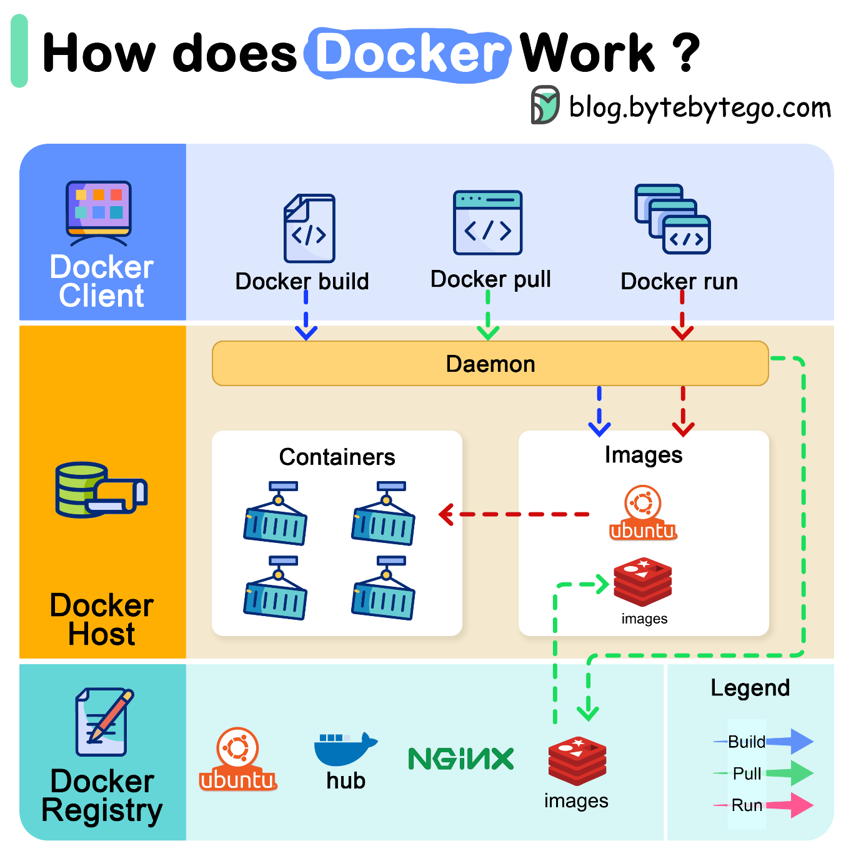
🌍 Real-World Example
Think of Zomato/Swiggy:
- You (Client) → place order
- Restaurant (Daemon) → prepares food
- Warehouse (Registry) → stores ingredients

🔄 14. DOCKER LIFECYCLE

Stages
1. Build
Create image
2. Ship
Push to registry
3. Run
Start container

Container States
- Created
- Running
- Paused
- Stopped

Docker Daemon:
Docker Daemon is the brain of Docker that runs in the background.
⚙️ Technical Explanation
- Runs as dockerd
- Manages:
  - Containers
  - Images
  - Networks
  - Volumes
- Listens to API requests from Docker CLI
🌍 Real-World Example
Like a restaurant chef:
- Takes orders (commands)
- Prepares dishes (containers)
- Uses stored ingredients (images)
🧠 FINAL SUMMARY (VERY IMPORTANT)
- 👉 Virtualization = heavy (VMs)
👉 Containerization = lightweight
- 👉 Namespaces = isolation
👉 cgroups = control
- 👉 Image = blueprint
👉 Container = running app
- 👉 Registry = storage
- 👉 Docker = fast + portable + scalable
- • Docker Architecture → Client + Daemon + Registry
- • Docker Daemon → executes commands
- • Docker CLI → user interface
- • Docker Hub → image storage
- • Container → running app
- • Image → blueprint
- • Network → communication
- • Volume → storage
- • Layering → efficient image building

Relationship Between Image and container
1️⃣ Blueprint and House Example (Most Common)
Image → Blueprint
Container → House
Explanation
- A blueprint is the design of a house.
- Using the same blueprint, you can build many houses.
Relation
Blueprint (Docker Image)
↓
House 1 (Container)
House 2 (Container)
House 3 (Container)
So:
- Docker Image = Blueprint
- Docker Container = Actual House

2️⃣ Class and Object Example (Programming)
Since you are a CSE student, this example is very useful.
Concept | Example
Class | Docker Image
Object | Docker Container
Example
Class → Car
Objects → Car1, Car2, Car3
Similarly:
Image → nginx
Containers → nginx1, nginx2, nginx3
Commands example:
docker run -d --name web1 nginx
docker run -d --name web2 nginx
docker run -d --name web3 nginx

3️⃣ Recipe and Dish Example
Image → Recipe
Container → Cooked Food
Example:
Recipe → Pizza Recipe
Dish → Pizza
Using the same recipe, you can make many pizzas.
Recipe (Image)
↓
Pizza1 (Container)
Pizza2 (Container)
Pizza3 (Container)

4️⃣ Movie File and Movie Player Example
Image → Movie file
Container → Movie running in player
Example:
Movie file → Avengers.mp4
Running movie → Playing on screen
Similarly:
Image → Python Image
Container → Running Python environment
Command:
docker run -it python

5️⃣ Real DevOps Example (Website Deployment)
Imagine a company wants to run a website.
Step 1: Create Image
Image → Nginx + Website code
Step 2: Run Multiple Containers
Container 1 → Website server
Container 2 → Website server
Container 3 → Website server
Commands:
docker run -d --name web1 -p 8081:80 nginx
docker run -d --name web2 -p 8082:80 nginx
docker run -d --name web3 -p 8083:80 nginx
This is used for load balancing in real companies.

⭐ One-Line Real Explanation
👉 Docker Image is the template.
Docker Container is the running application created from that template.

Can multiple containers run from one image?
Answer:
Yes. One Docker image can create multiple containers.
Example:
docker run -d --name web1 nginx
docker run -d --name web2 nginx
docker run -d --name web3 nginx
Here:
Image → nginx
Containers → web1, web2, web3

Commands :
- Docker –version check current version of docker installed in device
- Docker login login with user name and password
- Docker info Displays system-wide Docker information (containers, images, storage driver).
- docker history httpd Shows the history of a docker image with the image name mentioned in the command

- Docker pull nginx download the Nginx Docker image
- docker inspect nginx is used to view detailed information (metadata) about a Docker object like an image or container.
- Docker images list all Docker images stored locally on your system.
- Docker create nginx create a new container from the Nginx image, but it does NOT start it.
- Docker ps list all currently running Docker containers.
- Docker ps -a list ALL Docker containers, including(Running containers ,Stopped containers ,Exited containers)
- Docker start start an existing (stopped or created) Docker container.
- Docker create --name nginx_web nginx create a new container from the Nginx image and assign it a custom name, but it does NOT start it.
- docker run --name nginx_web nginx Create and start a container from the Nginx image and assign it a custom name(instead of create ,start run command both in single command)
Docker Run optional commands:
- -it: Runs the container in interactive mode, allowing you to interact with the container through the command line.
- -d: Runs the container in the background.
- -- name: Specifies a name for the container.
--rm: Automatically removes the container when it exits.
- -p: Maps a host port to a container port.
- -e / --env: Sets an environment variable inside the container.
- -v: Mounts a host volume inside the container.

What are Environment Variables in Docker?
Definition :
Environment variables in Docker are key-value pairs used to pass configuration information to containers at runtime.
Explanation:
Environment variables allow you to customize container behavior without changing the image. They are injected into the container’s environment and can be accessed by applications running inside it.
Example:
docker run -it -e MY_NAME=Harpreet ubuntu bash
 :result
Multiple Environment Variables in Docker:
- docker run -e APP_ENV=production -e APP_VERSION=1.0 nginx multiple environment variables using multiple -e flags
Example:
Command:
docker run -d -e MYSQL_ROOT_PASSWORD=root123 -e MYSQL_DATABASE=college -e MYSQL_USER=admin -e MYSQL_PASSWORD=admin123 mysql:8 locally creating database with user and password using environment variables .
docker exec -it 4c4a7f8aaa74 mysql -u root -p password authentication to connect to mysql database
SHOW DATABASES; shows the exsisting databases.

- docker run -d --name nginx_web nginx create and start a container from the Nginx image in detached mode with a custom name.
- docker run httpd echo “Hello, World!” new container from the ‘httpd ’ image and executes the ‘echo’ command with the argument “Hello, World!”.
- Docker kill <container_name> immediately stop a running Docker container by force.
- docker exec -it <container_name> /bin/bash open an interactive terminal inside a running container.
- docker rm delete/remove a Docker container.
- docker rmi delete/remove a Docker image.
- docker rm $(docker ps -a -q) remove ALL Docker containers (stopped ones) from your system.
- docker container prune Remove all stopped containers
- docker inspect <container_id/name> Show detailed info about a container
- docker logs <container_id/name> View container logs
- docker stats <container_id/name> Display resource usage stats of a container
- docker cp my_app:/project/report.txt C:\Users\hp\Desktop to copy container files into locally
3. Container Interaction with Host
- Execute a command inside a running container
- docker exec -it <container_id/name> <command>
- Attach to a running container's interactive shell
- docker attach <container_id/name>
- Copy files between container and host
  - From container to host:
  - docker cp <container_id>:<container_path> <host_path>
  - From host to container:
  - docker cp <host_path> <container_id>:<container_path>
Commands for CI with Host
- docker exec -it Container ID ls /
- docker exec -it Container ID /bin/bash
- mkdir /data
- echo "Hello Docker" > /data/test.txt
- exit
- docker attach Container ID
- docker cp Container ID:/data/test.txt C:\Users\HP\Desktop\
- docker cp C:\Users\HP\Desktop\test.txt Container ID :/data/sample.txt
- docker exec -it Container ID ls /data
- docker exec -it Container ID cat /data/sample.txt

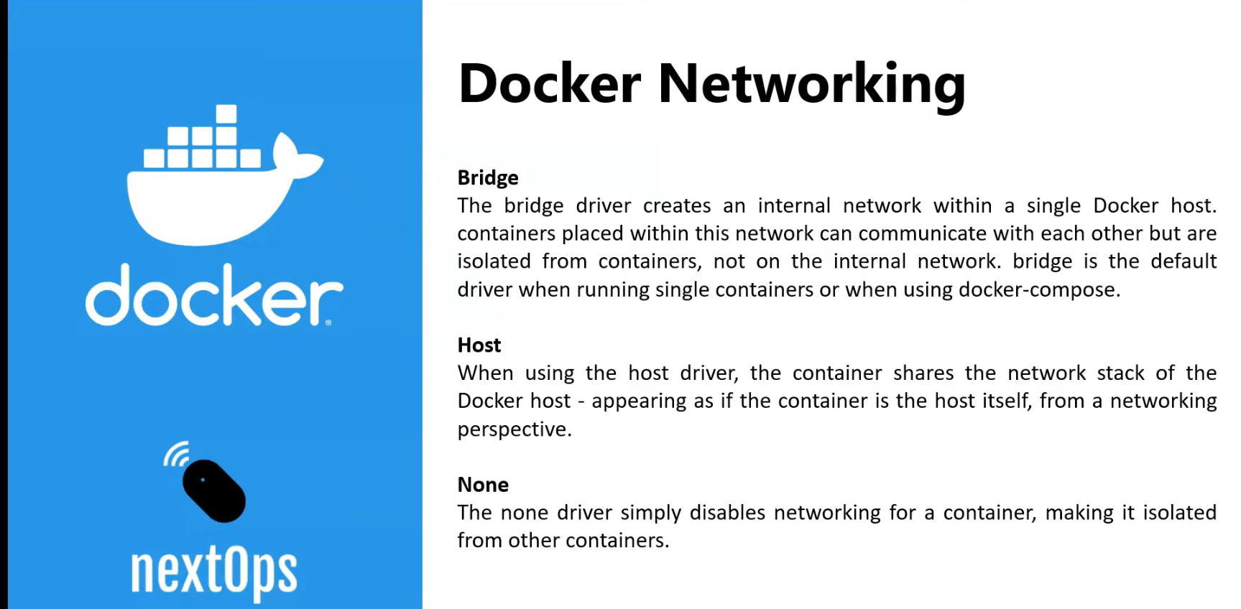
- docker network ls list all Docker networks available on your system.
- docker run -d --name httpd01 -p 8080:80 httpd create and run an Apache web server container in the background with port mapping and a custom name.
- docker run -d --name http02 --net host httpd runs an Apache HTTP server container using the host network directly.
- curl http://localhost:8080 Sends a request to verify the web page output from the container.

Docker Volume: A Docker Volume is a persistent storage mechanism used to store data outside the container, so data is not lost when the container stops or is deleted.
Default Location of Docker Volumes:
/var/lib/docker/volumes/
1. How Docker Volumes are Created
✅ Method 1: Manually create
docker volume create myvolume
👉 Creates an empty volume named myvolume
✅ Method 2: Automatically (during container run)
docker run -d -v myvolume:/usr/share/nginx/html nginx
2. Where Docker Volumes are Stored
📍 Default Location (Linux)
/var/lib/docker/volumes/
👉 Inside it:
/var/lib/docker/volumes/myvolume/_data
✔️ _data = actual stored files

Commands:
- Docker volume ls listed all available volumes
- docker volume rm <volume_name> delete/remove a Docker volume.
- docker volume prune remove all unused Docker volumes from the system.
Steps to create a volume and assign to container to use that volume:
- docker volume create <volume_name> create a new Docker volume
- docker volume inspect <volume_name> view detailed information (metadata) about a Docker volume in JSON format.
- docker run -it --volumes-from srv02 --name srv03 centos /bin/bash This command creates a new container (srv03) and shares volumes from another container (srv02).
- docker run -it --name=srv01 --mount source=testvol1,destination=/data centos:7 creates and runs a CentOS container with a Docker volume mounted inside it.
- docker run -it --name srv04 -v testvol1:/data centos
cd /data
echo "Hello from Docker Volume" > file1.txt
cat file1.txt

Tasks:
1)
- Run Ubuntu container
- Pass -e COLLEGE=CSE
- Show echo $COLLEGE
- Stop container then check what happened
solution:
- docker run -it -e COLLEGE=CSE ubuntu bash Run Ubuntu Container with Env Variable
- echo $COLLEGE Show the Variable

2. You are a DevOps engineer in a startup company. The development team asks you to quickly deploy a simple web page that displays the message: Use the official httpd Docker image. Run the container so it is accessible on port 8080 of the host machine. Create or update an HTML file inside the container to display the required message. Verify the output using a command-line tool. Properly stop and remove the container after testing.

Solution:
1. docker run -d -p 8080:80 --name myhttpd httpd Starts an Apache container in background and exposes it on port 8080.

2. docker exec -it myhttpd bash Opens an interactive terminal inside the running container.
3. echo "<h1>Welcome to My DevOps Project</h1>" > /usr/local/apache2/htdocs/index.html Creates or updates the web page with a custom message.
4. curl http://localhost:8080 Sends a request to verify the web page output from the container.

3.How would you use the docker run command with -it, -e, -v, and --name to:
• Set an environment variable APP_ENV=production.
• Bind a local directory /app/data to /data inside the container.
• Name the container my_app.
solution:

- mkdir C:\app\data Create Local Folder (on Windows)
- docker run -it --name my_app -e APP_ENV=production -v C:\app\data:/data ubuntu bash Run Container
- echo $APP_ENV Check Environment Variable
- echo "Hello this is my first program" > /data/test.txt Create File in Mounted Folder
- cat /data/test.txt Check File
- echo "Second line added" >> /data/test.txt Append Data
- cat /data/test.txt Verify Again
4. Inside this same running container, you are required to:
Create a new directory named /project.
Inside /project, create a file called report.txt.
Add the following text inside the file:
This is our container interaction with our host machine.
Verify the file content.
Copy report.txt from the container to your Desktop.
Create another file named notes.txt in the same /project directory.
Append the text:
Verify that both files exist inside /project. clear steps to do this task

Solution:
- docker run -it --name my_app ubuntu bash
- mkdir /project
- cd /project
- echo "This is our container interaction with our host machine." > report.txt
- cat report.txt
- docker cp my_app:/project/report.txt C:\Users\hp\Desktop to copy container files into locally
- echo "This is notes file" > notes.txt
- echo "Second line added" >> notes.txt
- ls /project
- cat notes.txt

5. Your backend team reports that their MySQL container is failing to start.
- Use mysql:8 image.
- Set required environment variables:
  - MYSQL_ROOT_PASSWORD
  - MYSQL_DATABASE
  - MYSQL_USER
  - MYSQL_PASSWORD
- Run in background.
- Expose port 3306 to host port 3307.
- Check logs to identify errors.
- Enter inside container to verify database.
- Stop and remove container after debugging.
Solution:
- docker pull mysql:8
- docker run -d --name mysql-debug -p 3307:3306 -e MYSQL_ROOT_PASSWORD=root123 -e MYSQL_DATABASE=mydb -e MYSQL_USER=user1 -e MYSQL_PASSWORD=user123 mysql:8
- docker ps
- docker exec -it mysql-debug bash
- mysql -u root -p
- enter the password
- SHOW DATABASES;
- Exit
- Stop mysql-debug
- Rm mysql-debug

TASK 6: ENV VARIABLES + MULTIPLE VALUES
• RUN MYSQL CONTAINER
• SET MULTIPLE ENV VARIABLES
• VERIFY DATABASE
✅ SOLUTION:
docker run -d --name mysql_test -e MYSQL_ROOT_PASSWORD=root123 -e MYSQL_DATABASE=testdb -e MYSQL_USER=admin -e MYSQL_PASSWORD=admin123 mysql:8 creating multiple env variables
docker exec -it mysql_test bash to enter into interactive mode of already existing running container .
mysql -u root -p to log in into mysql using password root
SHOW DATABASES; shows the databases of created

TASK 7 FILE COPY (HOST ↔ CONTAINER)
• CREATE FILE INSIDE CONTAINER
• COPY TO HOST
• COPY BACK TO CONTAINER
✅ SOLUTION:
docker run -it --name file_test ubuntu bash
mkdir /data
echo "Docker File Transfer" > /data/test.txt
exit
docker cp file_test:/data/test.txt C:\Users\HP\Desktop
docker cp C:\Users\HP\Desktop\test.txt file_test:/data/sample.txt
docker exec -it file_test cat /data/sample.txt

TASK 8: VOLUME USAGE
• CREATE VOLUME
• ATTACH TO CONTAINER
• STORE FILE
• VERIFY PERSISTENCE
✅ SOLUTION:
docker volume create myvol
docker run -it --name vol_test -v myvol:/data ubuntu bash
echo "Persistent Data" > /data/file.txt
exit
docker run -it --name vol_test2 -v myvol:/data ubuntu bash
cat /data/file.txt

TASK 9: FULL WEB SERVER + CUSTOM PAGE
You are deploying a production web app using Docker.
• RUN httpd CONTAINER
• MAP PORT 8081
• CREATE CUSTOM HTML PAGE
• VERIFY OUTPUT
• CHECK LOGS
• STOP & REMOVE
✅ SOLUTION:
docker run -d --name prod_web -p 8081:80 httpd
docker exec -it prod_web bash
echo "<h1>Production Server Running</h1>" > /usr/local/apache2/htdocs/index.html
exit
curl http://localhost:8081
docker logs prod_web
docker stop prod_web
docker rm prod_web

What is Dockerfile?
A Dockerfile is a script that contains instructions to build a Docker image automatically.
FROM defines the base image used to start the build process.

ADD copies the files from a source on the host into the container's own filesystem at the set destination.

COPY copies the files from a source on the host into the container's own filesystem at the set destination.

CMD can be used for executing a specific command withir the container.

ENTRYPOINT sets a default application to be used every time a container is created with the image.

ENV sets environment variables.
EXPOSE associates a specific port to enable networking between the container and to the outside. D

MAINTAINER defines a full name and email address of the image creator.

RUN is the central executing directive for Dockerfiles.

USER sets the UID (or username) which is to run the container.

VOLUME is used to enable access from the container to a directory on the host machine.

WORKDIR sets the path where the command, defined with CMD, is to be executed.

LABEL allows you to add a label to your docker image.

Process:
- Creating new image from ubuntu adding apache webserver

FROM ubuntu:18.04
LABEL maintainer="thecloudspoc@gmail.com"
RUN apt-get update && apt-get install -y apache2
EXPOSE 80
ENTRYPOINT ["/usr/sbin/apachectl", "-D", "FOREGROUND"]
- mkdir Dockerfiles
- cd Dockerfiles
- mkdir ubuntu_apache2_plain
- cd ubuntu_apache2_plain
- New-Item Dockerfile
- notepad Dockerfile
- copy and paste the ubuntu image code into Dockerfile.txt
- docker build -t parapatichennakesavarao/ubapache2 .
- docker run -d -p 8080:80 parapatichennakesavarao/ubapache2
it shows the ubuntu apache predefined page
if we want to custome webpage
after creating Dockerfile , create new-item or file index.html add html code to display in webserver and after build the container and run it by port
pushing created image into hub.docker.com
- docker tag parapatichennakesavarao/ubapache2 chenna2004/ubapache2:v1 creating tag for image
- docker push chenna2004/ubapache2:v1 pushing the created image into docker hub

Example 2:
- A developer is building a Java-based application and wants to containerize it using Docker. The application should be accessible from the host system and must communicate with another service container. Data generated by the application should persist even if the container is removed. 1. Create a Dockerfile for a Java application using: FROM, WORKDIR, COPY, RUN, CMD, EXPOSE
2. Build Docker Image
3. Create a Custom Bridge Network
4. Run Two Containers
5. Implement Port Mapping
6. Use Named Volume
7. Demonstrate Copy-on-Write
8. List and Explain Image Layers

🧠 What the Question Is Asking (Big Picture)
You’re a developer with a Java app. You need to:
- Package it → Docker Image
- Run it → Container
- Access it from your laptop → Port mapping
- Make it talk to another service → Networking
- Save its data permanently → Volume
- Show Docker internals → Copy-on-Write & Layers

Solution: ✅ STEP 1: Create Project Folder
💻 Commands:
mkdir Dockerfiles
cd Dockerfiles
mkdir java_project
cd java_project
🎯 Purpose:
- Organize project files
- Docker builds using current folder (build context)
✅ STEP 2: Create Java Application
💻 Command:
notepad Main.java
📄 Code:
public class Main {
public static void main(String[] args) {
System.out.println("Hello from Docker Java App!");
}
}
🎯 Purpose:
- This is the application we will containerize
✅ 3) Create a Dockerfile
✔ What you do
Write a Dockerfile with required instructions.
FROM eclipse-temurin:17
WORKDIR /app
COPY . /app
RUN apt-get update && apt-get install -y iputils-ping
RUN javac Main.java
EXPOSE 8080
CMD ["sh", "-c", "java Main && tail -f /dev/null"]
🎯 Why each instruction is used
- FROM → Base environment (Java already installed)
- WORKDIR → Where commands will run inside container
- COPY → Bring your code into container
- RUN → Install tools + compile code
- EXPOSE → Declare application port (documentation + networking hint)
- CMD → What runs when container starts
👉 This step = Define how your app becomes a container

✅ 4) Build Docker Image
✔ Command
docker build -t java-app .
🎯 Purpose
- Converts Dockerfile → Image
- Image = portable package of your app
👉 Think: “Creating a software package”

✅ 5) Create Custom Bridge Network
✔ Command
docker network create my-network
🎯 Purpose
- Allows containers to communicate using names
- Acts like a private network
👉 Without this → containers are isolated

✅ 6) Run Two Containers
✔ Commands
docker run -dit --name service1 --network my-network java-app
docker run -dit --name service2 --network my-network nginx
🎯 Purpose
- service1 = your Java app
- service2 = another service (like web server)
👉 Now they can communicate:
docker exec -it service1 ping service2
👉 This simulates microservices architecture

✅ 7) Implement Port Mapping
✔ Command
docker run -dit -p 8080:8080 --name java-container java-app
🎯 Purpose
- Connect container → your laptop
👉 Format:
host_port : container_port
👉 Now accessible via:
http://localhost:8080
👉 Without this → container is NOT accessible externally

✅ 8) Use Named Volume
✔ Commands
docker volume create my-volume
docker run -dit --name java-container -v my-volume:/app/data java-app
🎯 Purpose
- Store data outside container
- Data survives even if container is deleted
👉 Without volume:
❌ Data lost when container is removed
👉 With volume:
✅ Data persists

✅ 9) Demonstrate Copy-on-Write (CoW)
✔ Command
docker run -it java-app bash
Inside container:
echo "Hello" > file.txt
🎯 Concept
- Docker images = read-only layers
- Container = writable layer
👉 When you modify something:
- Docker creates a new layer
- Original image remains unchanged
👉 This is Copy-on-Write

✅ 10) List and Explain Image Layers
✔ Command
docker history java-app
🎯 Purpose
Shows layers like:

Example 3:
A DevOps engineer wants to deploy applications in a secure environment without relying on Docker Hub. They need to set up a private registry, push images, and verify them using API calls. The system must also demonstrate differences between host and bridge networking.
• Create a Private Docker Registry
• Build a Docker Image
• Tag and Push Image to Private Registry
• Verify Registry Using curl API
• Run Container in Host Network Mode
• Explain Difference: Host vs Bridge
• Pull Image from Private Registry
• Demonstrate Authentication Concept
Solution:
🧠 What the Question Is Asking (Big Picture)
You are a DevOps engineer who must:
- Avoid public registries like Docker Hub
- Store images in your own private registry
- Push & pull images securely
- Verify registry via API (curl)
- Understand networking (Host vs Bridge)
👉 This is a secure deployment workflow

✅ 1) Create a Private Docker Registry
✔ What to do
docker run -d -p 5000:5000 --name registry registry:2
🎯 Purpose
- Starts your own image server
- Accessible at:
http://localhost:5000
👉 No need to use public registry → more secure

✅ 2) Build a Docker Image (Python app)
✔ Create app
notepad app.py
print("Hello from private registry!")
✔ Create Dockerfile
notepad Dockerfile
FROM python:3.10
WORKDIR /app
COPY . /app
CMD ["python", "app.py"]
✔ Build image
docker build -t my-app .
🎯 Purpose
- Converts your app → Docker Image
✅ 3) Tag and Push Image to Private Registry
✔ Tag
docker tag my-app localhost:5000/my-app
✔ Push
docker push localhost:5000/my-app
🎯 Purpose
- Tag = tells Docker where to push
- Push = uploads image to your private registry
👉 Now image is stored inside your system
✅ 4) Verify Registry Using curl API
✔ Command
curl http://localhost:5000/v2/_catalog
🎯 Purpose
- Checks what images exist in registry
✔ Output example
{"repositories":["my-app"]}
👉 Confirms image is successfully stored
✅ 5) Run Container in Host Network Mode
✔ Command
docker run -dit --network host my-app
🎯 Purpose
- Container shares host’s network
- No port mapping needed
👉 App runs directly on host ports

⚠️ Note (IMPORTANT)
- Host network works fully on Linux
- On Windows → concept explanation is enough for exam
✅ 6) Difference: Host vs Bridge
🔹 Bridge Network (Default)
Feature | Bridge
Isolation | Yes
IP | Separate
Port Mapping | Required
Example | -p 8080:8080

🔹 Host Network
Feature | Host
Isolation | No
IP | Same as host
Port Mapping | Not needed
Performance | Faster

🎯 Exam Answer Line
Bridge network provides isolation and requires port mapping, while host network shares the host’s network directly without isolation.

✅ 7) Pull Image from Private Registry
✔ Command
docker pull localhost:5000/my-app
🎯 Purpose
- Retrieve image from private registry
- Used in deployment

✅ 8) Demonstrate Authentication Concept
🧠 Concept
By default:
❌ Registry is open
We add authentication for:
✔ Security
✔ Access control

✔ Example
docker login localhost:5000
Then:
docker push localhost:5000/my-app

🎯 Purpose
- Only authorized users can push/pull images

🔴 HARD SCENARIO 1 (FULL STACK DEPLOYMENT)
❓ QUESTION
A startup is building a microservice-based web application using Docker.
You are required to deploy a frontend (nginx) and backend (Node.js app) such that:
• Backend runs on port 5000
• Frontend runs on port 80 and connects to backend
• Both containers must communicate securely
• Application data must persist
• Backend image must be built using Dockerfile
• Use environment variables for configuration
• Verify communication using curl
• Show logs and inspect containers
👉 Tasks:
- Create Dockerfile for backend
- Build image
- Create custom bridge network
- Run backend container with env variables
- Run frontend container
- Implement port mapping
- Use volume for backend data
- Verify frontend ↔ backend communication
- Debug using logs & inspect

🔴 HARD SCENARIO 2 (DATA + STORAGE + DEBUGGING)
❓ QUESTION
A company is running a database service using MySQL container. After restarting the container, all data is lost.
You are asked to fix and debug the system.
👉 Requirements:
• Run MySQL container with required environment variables
• Ensure data persistence using named volumes
• Map port 3306 → 3308
• Create a database and table
• Restart container and verify data exists
• Use docker logs and inspect for debugging
• Copy database dump file from container to host
• Show resource usage of container

🔴 HARD SCENARIO 3 (PRIVATE REGISTRY + SECURITY)
❓ QUESTION
Your company wants to avoid public registries like Docker Hub and maintain a secure internal system.
👉 Tasks:
• Create a private registry container
• Build a custom Python app image
• Tag image for private registry
• Push image to registry
• Verify registry using API (curl)
• Pull image from registry
• Run container using host network mode
• Compare host vs bridge networking practically
• Simulate authentication concept (login required)

🔴 HARD SCENARIO 4 (ADVANCED IMAGE + LAYERS + OPTIMIZATION)
❓ QUESTION
A DevOps team wants to optimize Docker image builds for a Java application.
👉 Requirements:
• Create Dockerfile using:
- FROM, WORKDIR, COPY, RUN, CMD, EXPOSE
• Build image
• Run container with port mapping
• Modify application file and rebuild image
• Demonstrate layer caching effect
• Use docker history to analyze layers
• Explain copy-on-write with practical example
• Use .dockerignore to optimize build context
• Compare image sizes before and after optimization

